1. Write a Python program to sum all the items in a list.

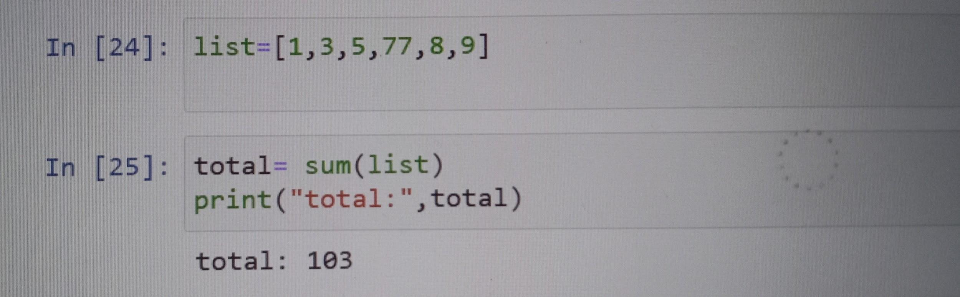

2. Write a Python program to get the largest number from a list.

3. Write a Python program to count the number of strings from a given list of strings. The string length is 2 or more and the first and last characters are the same.

Sample List : ['abc', 'xyz', 'aba', '1221']

Expected Result : 2

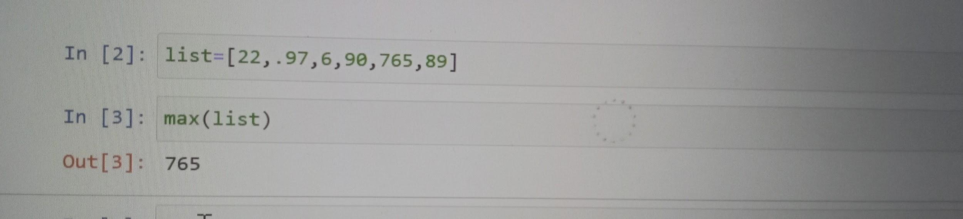

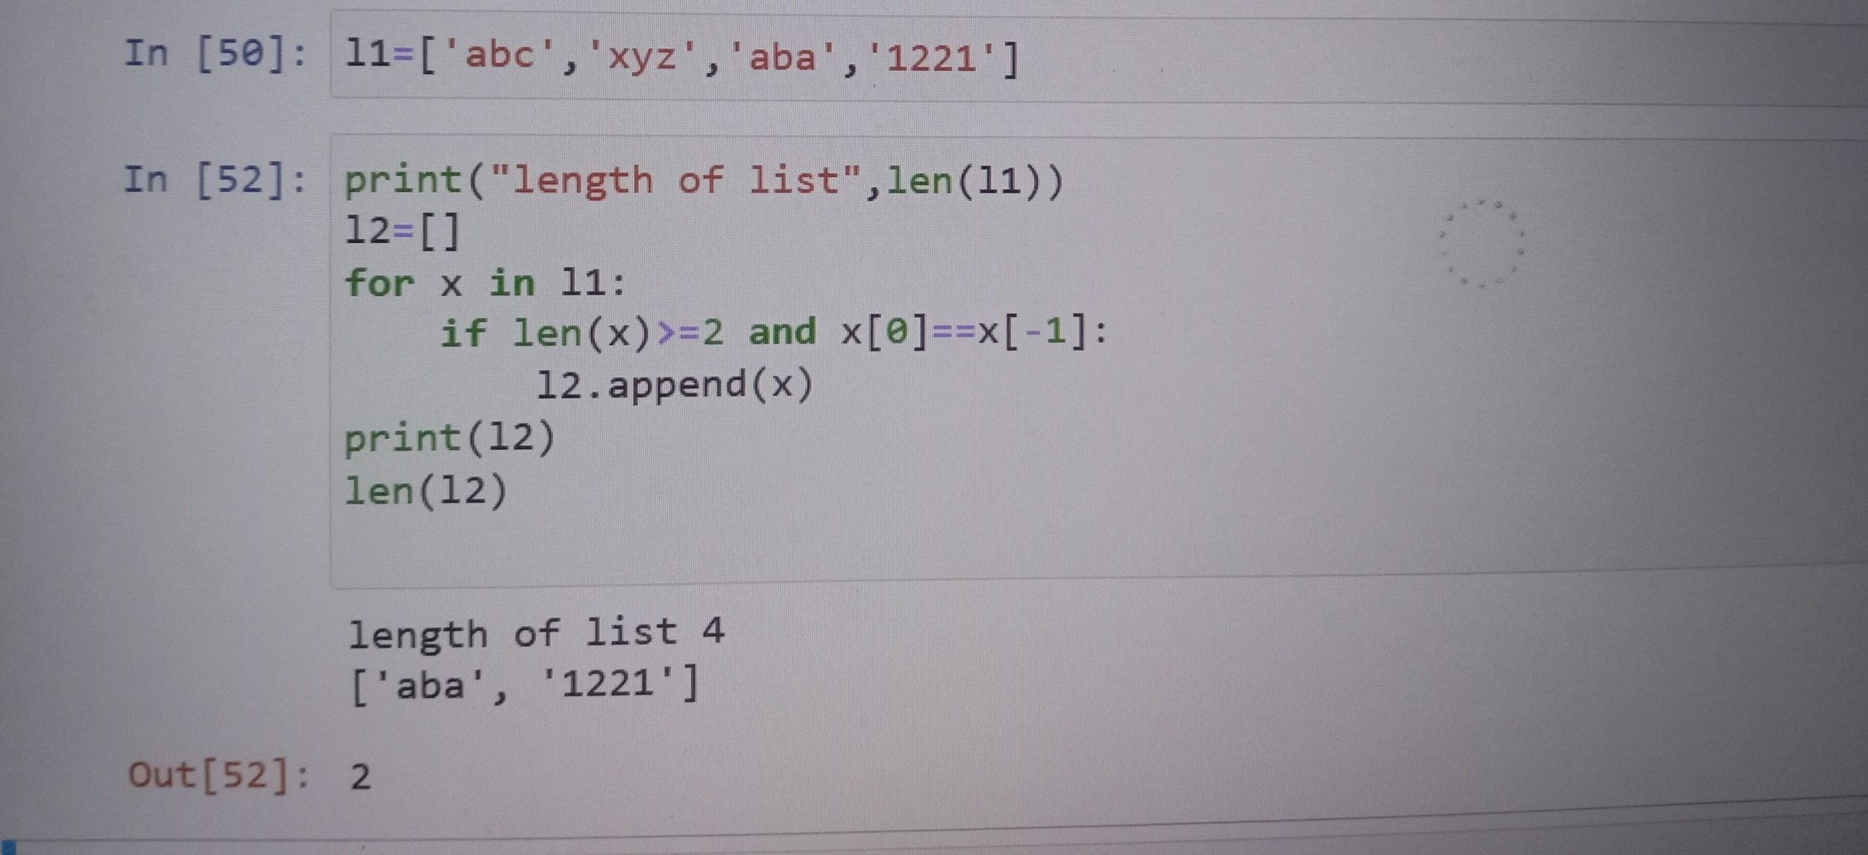

4. Write a Python program to remove duplicates from a list.

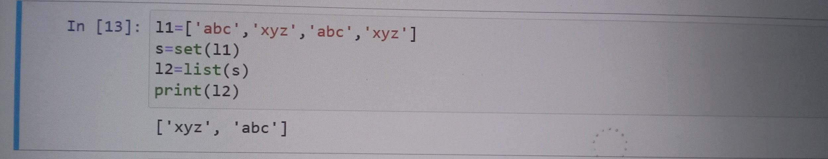

5. Write a Python program to check if a list is empty or not.

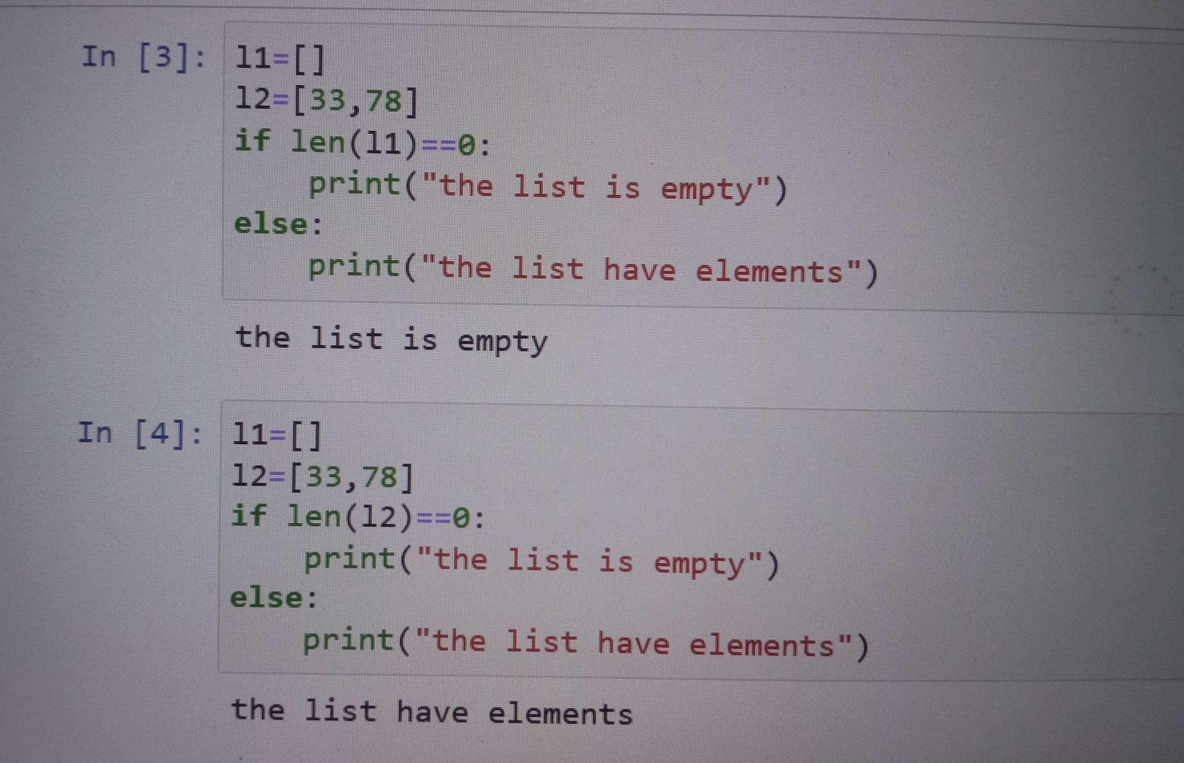

6. Write a Python program to filter the list if the length of the character is < 4

Sample List : ['abc', 'xyz', 'aba', '1221']

Expected Result: ['abc', 'xyz', 'aba']

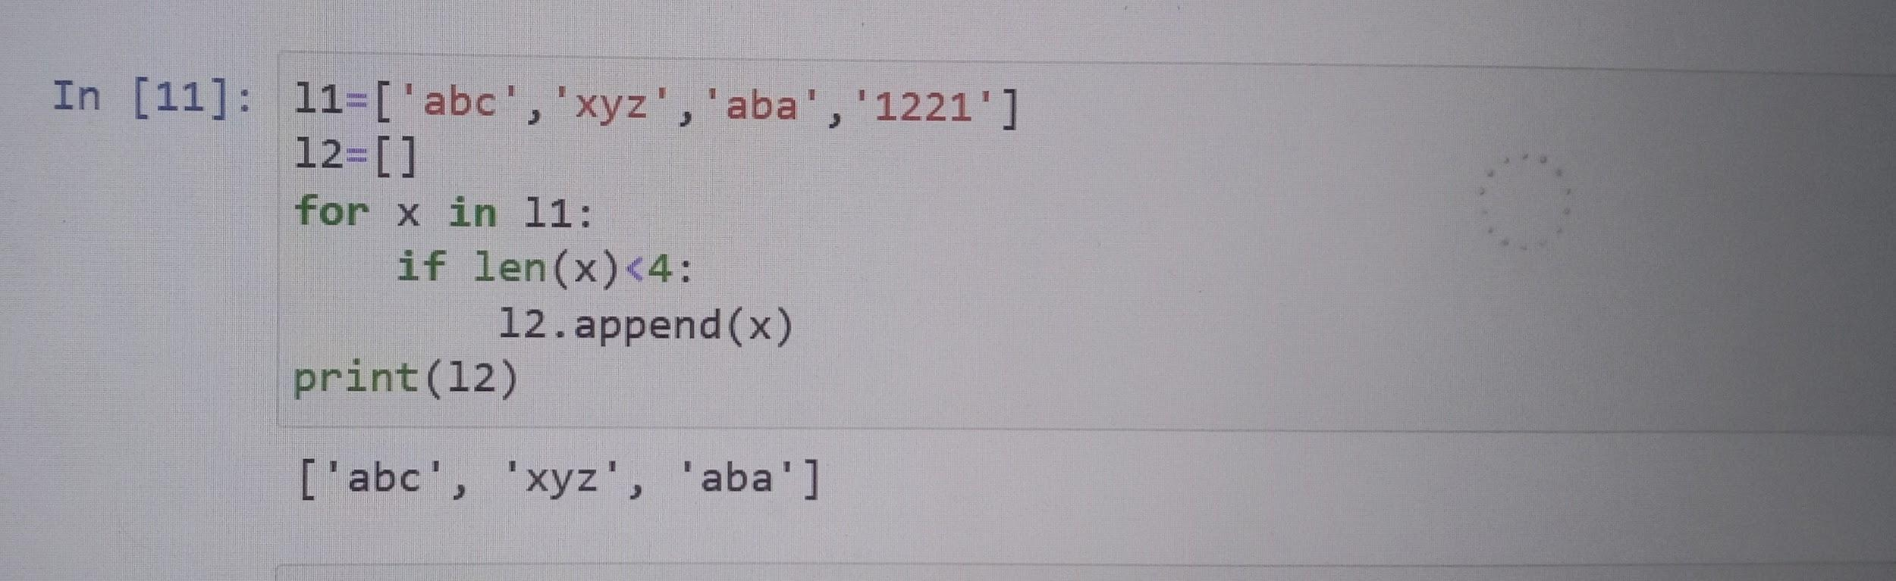

7.Write a Python program to find the second largest number in a list.

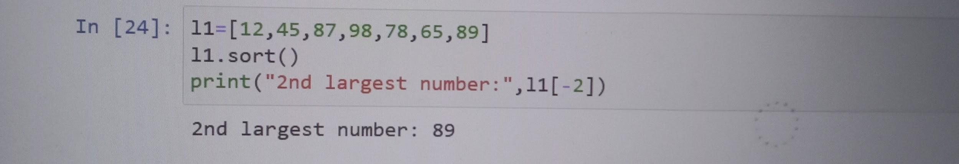

8. Write a Python program to reverse a list at a specific location.

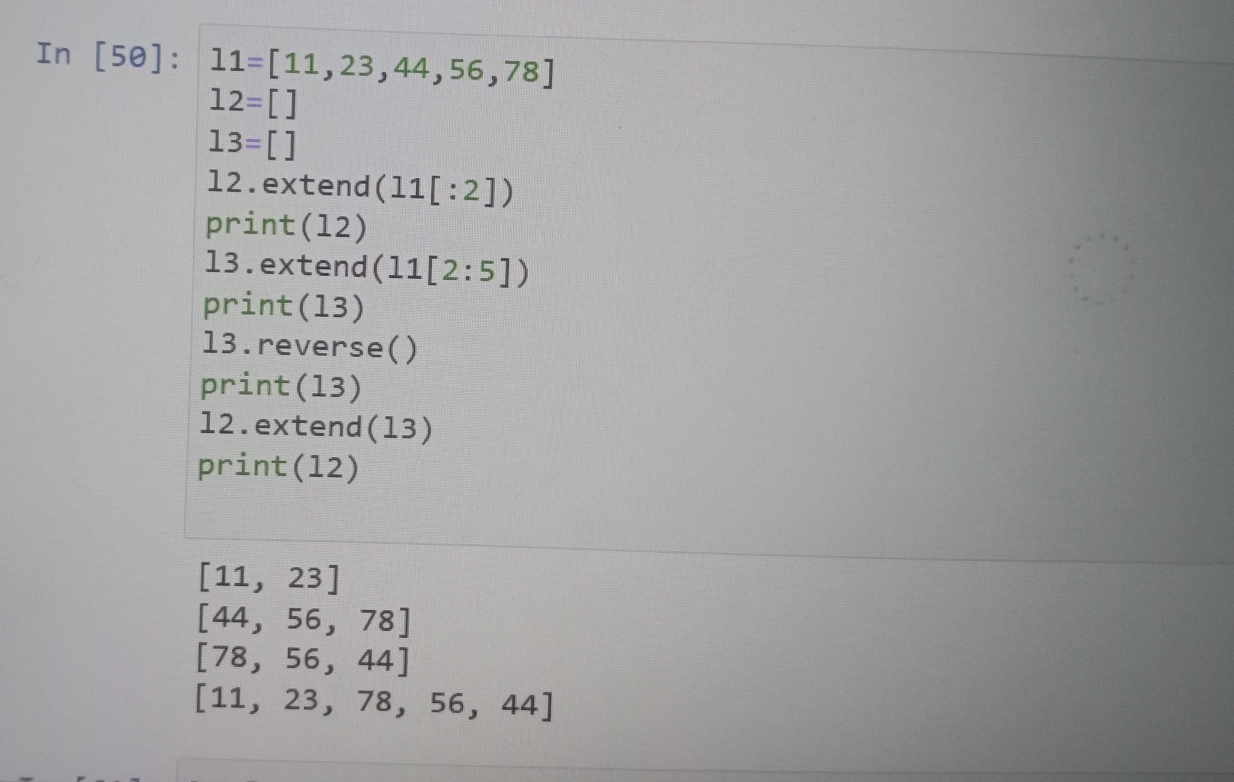

9. Write a Python program to check if a list is a palindrome or not. Return true otherwise false.

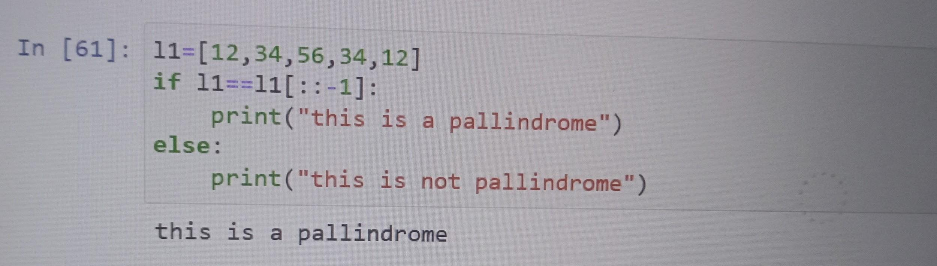

10. Write a Python a program to find the union and intersection of two lists.

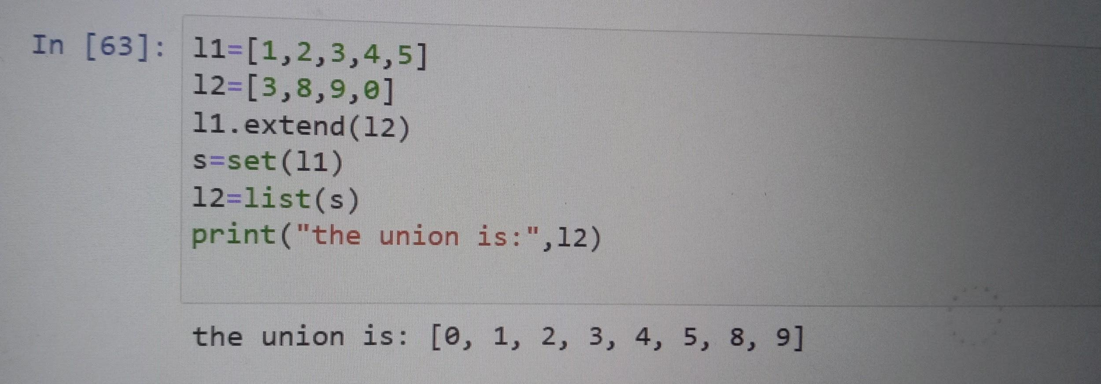

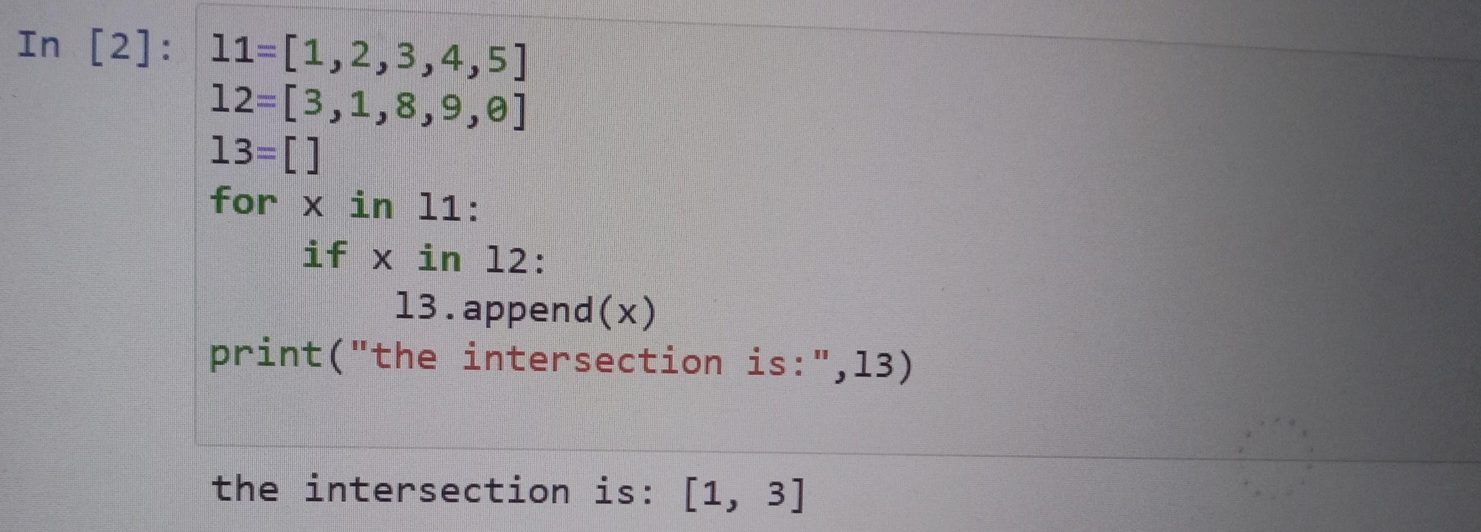

11.Write a Python script to sort (ascending and descending) a dictionary by value

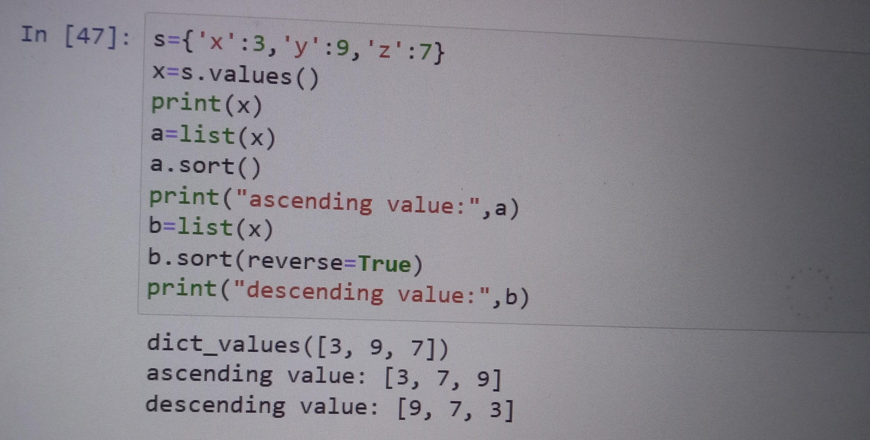

12. Write a Python script to check whether a given key already exists in a dictionary.

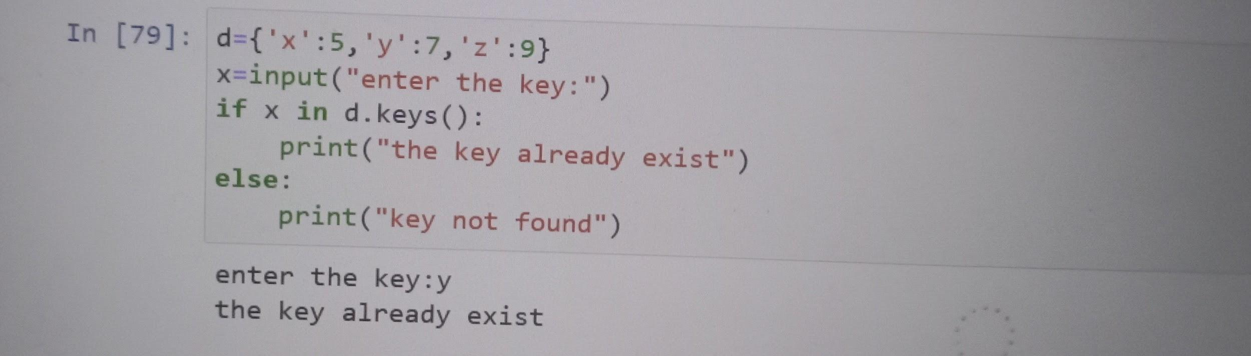

13.Write a Python program to sum all the values in a dictionary.

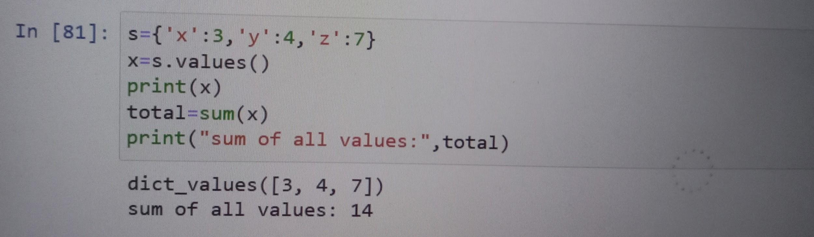

14.Write a Python program to create a dictionary with a number and its corresponding square from 1 to input number. And also check if the input number is less than 10

Eg:

Input : 3

Output : {1:1, 2:4, 3:9}

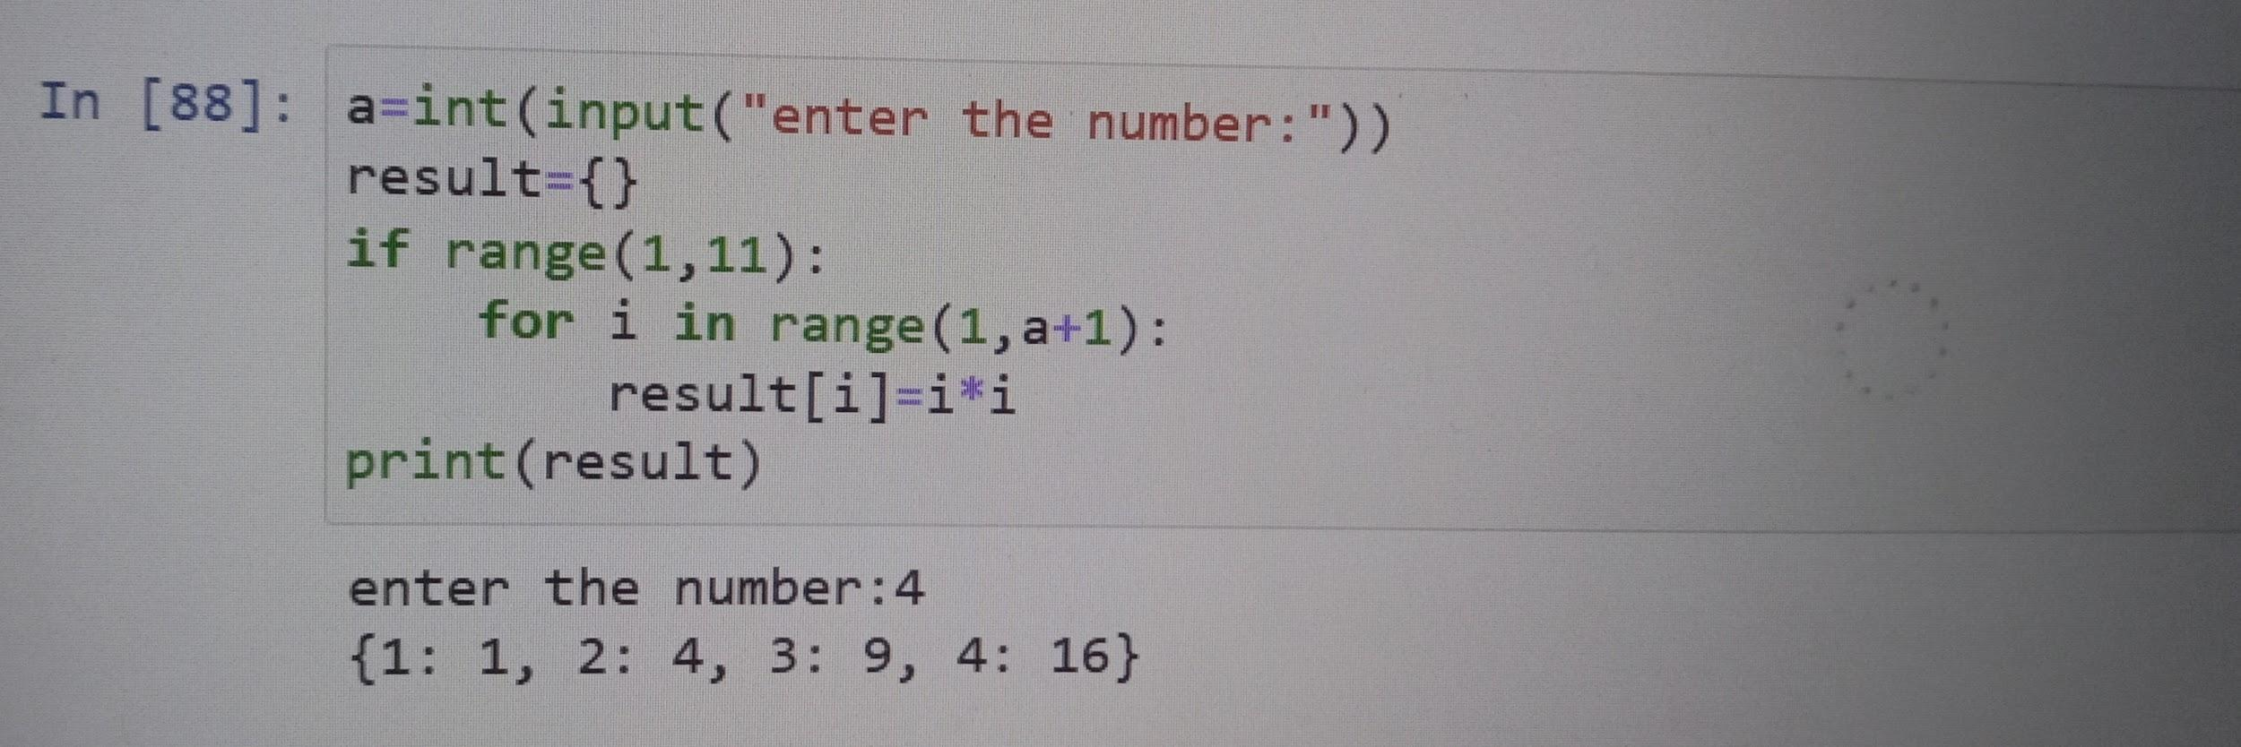

15.Write a Python program to sort a given dictionary by key.

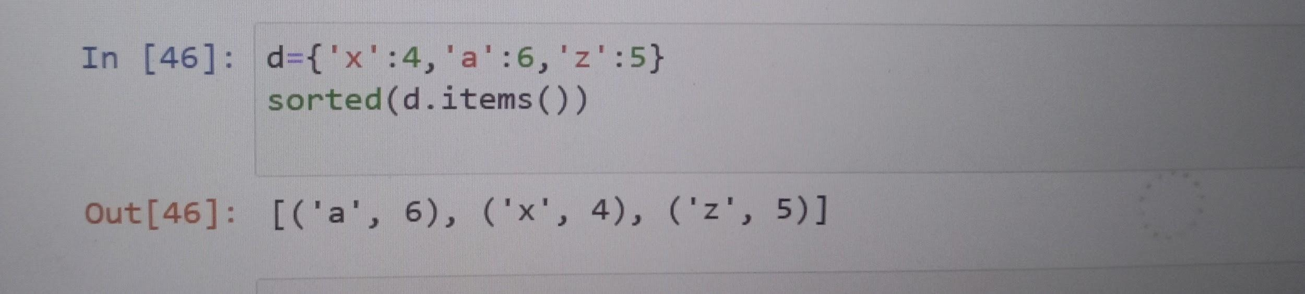

16. Write a Python program to create a dictionary from a string.

Note: Track the count of the letters from the string.

Sample string : 'learnpython'

Expected output: {'l': 1, 'e': 1, 'a': 1, 'r': 1, 'n': 2, 'p': 1, 'y': 1, 't': 1, 'h': 1, 'o': 1}

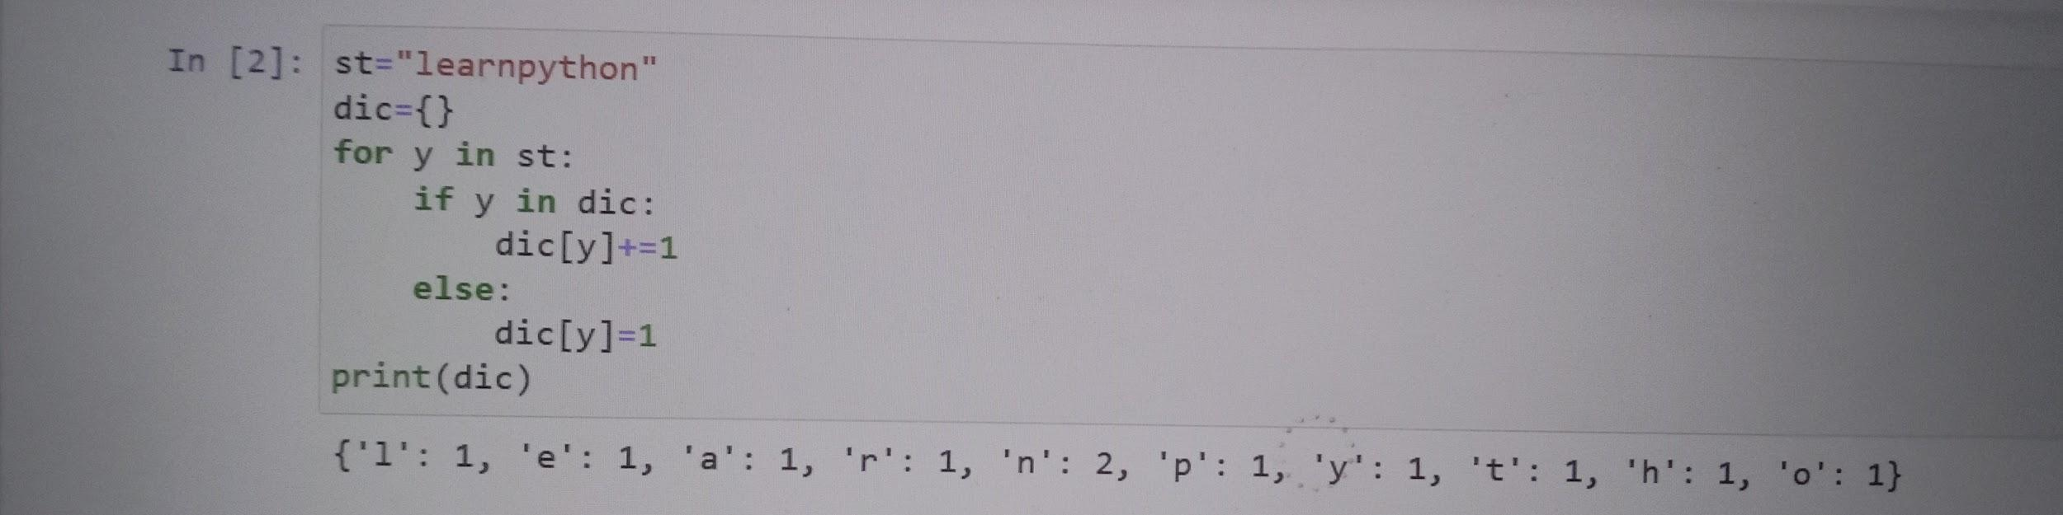

17. Write a Python program to get the top three items in a shop.

Sample data: {'item1': 45.50, 'item2':35, 'item3': 41.30, 'item4':55, 'item5': 24}

